Announcements  RATE INCREASE  EFFECTIVE ON THE NEXT BILLING CYCLE JANUARY 2023  As a reminder:  Your bill will increase by $4.83 for the base rate and $1.00 for 1000 gallon after your allotted 10,000 gallons per month.  For more information about the study conducted contact us at 530-257-7977.  Dates to Remember  Jan. 2nd – Office Closed in observance of New Years  Jan. 18th - Bills are Due 4:00pm to avoid a 10% Late Charge  Jan. 25th - 4:00pm Board Meeting  Jan. 31st – Bills for January (with new rate) will be going out. | Who We Are  About Us  At Leavitt Lake Community Services District, we are committed to providing safe, high quality water services to our community, while maintaining a standard of excellence in customer service and environmental conservation.  Contact Us  Phone: 530-257-7977  Email: LeavittCSD@frontiernet.net  Web: Leavittlake.Myruralwater.com  Leavitt Lake CSD is an equal opportunity service provider and employer.  Leavitt Lake community services district  471-830 Buffum Ln  Susanville, Ca 96130 | January  2023  Leavitt Lake community services district  - It is our mission to provide safe, high quality water and sewer services to our community.
Behind on your water or wastewater bills?  What is LIHWAP and how can it help?  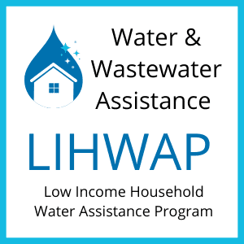  All Californians deserve access to safe and clean water, and many households need assistance now.  LIHWAP stands for the Low Income Household Water Assistance Program and it may be able to help you pay your water or wastewater utility bill.  LIHWAP is a federally funded program that offers low-income households a one-time payment to help pay outstanding bills for residential water or wastewater costs. In the wake of the COVID- | 19 pandemic, the federal government awarded California  funding to help households struggling to afford the costs of water, and many Californians in need may qualify.  The amount of help that you may get will depend on the past due balance of your household’s residential water and wastewater bills. Households whose utility payments are included in their rent may also be eligible for LIHWAP.  In addition, program participation is limited to households receiving services from water and wastewater providers enrolled in LIHWAP to receive the payment of assistance benefits.  LIHWAP can offer a one-time payment to help you:  1. Pay your residential water and wastewater utility bills.  2. Manage an emergency or water crisis, such as a service disconnection.  3. Prevent other adverse effects such as debt collection or placement of liens. | Go Paperless!  Going paperless is the simplest way to get your water/wastewater bill.  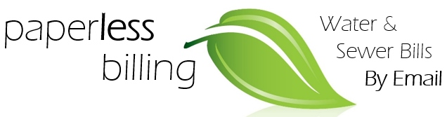  Instead of a monthly paper bill, you’ll receive an email with your amount due, due date, and details of usage for that billing cycle.  If you’re interested, send an e-mail to :  LeavittCSD1@frontier.com  And mention, “Paperless” and we will save your email to our billing registry for all your future billing.  Give us a call at 530-257-7977 for further details and information.

